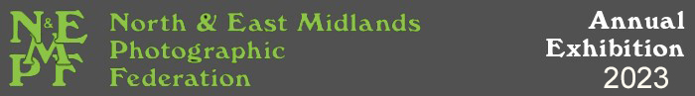

CLUB ENTRY FORM

To be completed and returned with ENTRY FEES TO:-

Gary Langley 9, Chiltern Way, Bestwood Park, Nottingham NG5 5NP

To arrive BEFORE SUNDAY 16th OCTOBER 2022

PLEASE USE BLOCK CAPITAL LETTERS

Club / Society

Name of person Responsible for Exhibition Entries

Email

Address

Postcode

Telephone No Emergency No
(Above details will be used to send catalogues, disks and return entries, unless otherwise stated)

If entries are to be hand delivered please state name of the Collector

CLUB/SOCIETY EXHIBITION ENTRY FEES

Number of entrants from Club /Society ____________

Number of Individual Print Panels @ £5 per panel £
Number of Individual Prints @ £1.25 each £
Number of Digital images @ £1.25 each £

TOTAL ENTRY FEE £

Additional Catalogues @ £3.00 each £

PDI & print Acceptances Show £15 for 1 show, £25 for both shows £

Postage and Packing for CD’s £5 £ 5.00

TOTAL ENCLOSED WITH THIS FORM £

Please make a cheque (one per club please) payable to: ‘North & East Midlands Photographic Federation’

Or payment can be sent electronically to:
Name: North and East Midlands Photographic Federation
Sort Code: 601323
Account Code: 97543578
Reference: must be name of Camera Club/Society
Please indicate if paying by Bank Transfer Yes/No

